# Lab 3

**Exercise 1:**

Note: 002  
  
Note: Result after following steps.

**Exercise 2:**

  
Note: Result after following directions.

**Exercise 3:**

**Exercise 4:**



**Exercise 5:**



  
Note: without write permissions

**Exercise 6:**

**Exercise 7:**

1. Removing read permissions by people submitting their exam papers facing downwards
2. Also by sending a report enclosed in a folder

**Exercise 8:**  
  
  
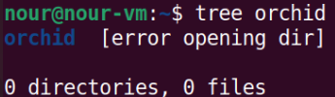  
  
Note: Write and Execute permissions must be active for vanda to be removed.

**Exercise 9:**

Note: `mkdir -p archive/Mgt/Q01` used.

Note: the operation worked

  
  
  


**Exercise 10:**

1. A, x. B, x (I tested it and it worked like that)
2. A, x, w. B, w, x.
3. A, x, w. B, none (with message), w (without message).   
   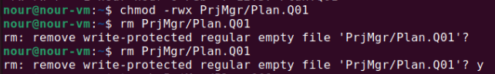  
   Note: The operation worked.  
   Text

   Description automatically generated  
   Note: The operation worked.